November 2017

Dear Journey Family,

Today I am excited to introduce you to the TRANSFORMED Special Offering that begins now and continues through January 31, 2018.

As we look back on the first 6 years of our church, it’s incredible to see how God has used and blessed us since our first service in February 2011. We have seen hundreds of people baptized, hundreds more come to faith in Christ, served thousands through outreach and community ministry initiatives, and we’ve done all of this to give the people of South Florida the best opportunity to become fully developing followers of Jesus.

2017 has been a year of transformation for our church, as we have moved from being a “portable” church meeting at Boca Raton High School and Grandview Preparatory School, to a church that now owns a building and is establishing a permanent presence in Boca Raton. The future is exciting, but we’ve only just begun.

And now as we look forward to 2018, I believe the TRANSFORMED Special Offering will allow us to deepen our impact for Jesus in South Florida and around the globe. Here’s how your giving to TRANSFORMED will allow us to do just that:

- Transforming OUR CHURCH Through Completing the Worship Center at our New Permanent Building

- Transforming OUR CITY Through Evangelism & Community Ministry

- Transforming OUR WORLD Through Supporting National and International Missionaries

Please read through this booklet to learn about this exciting opportunity for us to give sacrificially and expand our impact for Jesus. Will you begin praying now about what God would have you give (over and above your regular giving) to this Special Offering? Allow God to stretch your faith!

Together, let’s see our church, community and world TRANSFORMED like never before!

Jason Hatley
Lead Pastor, The Journey Church

P.S. This booklet will give you an overview of the Special Offering and answer many common questions. However, if you have any additional questions, please do not hesitate to contact me at 561.420.0606 x3 or jh@bocajourney.com.

TRANSFORMED SPECIAL OFFERING OVERVIEW

(Jesus) "You will be my witnesses, telling people about me everywhere - in Jerusalem, throughout Judea, in Samaria, and to the ends of the earth.” - Acts 1:8

The TRANSFORMED Special Offering is a call to sacrificial giving with a goal of $26,000 for three important ministry and mission initiatives:

Transforming OUR CHURCH Through Completing the Worship Center at our New Permanent Building
- Establishing a home for our church where we can develop leaders and disciples
- Creating a worship space where thousands will come to Christ in our community
- Providing a permanent ministry center where we can reach out to and serve our community

Transforming OUR CITY Through Evangelism & Community Ministry
- Reaching College Students through New Outreach Initiatives at FAU
- Sharing God's love through ongoing evangelism efforts in our community
- To meet the spiritual and physical needs of the poor in our area through Community Ministry
Transforming OUR WORLD Through Supporting National and International Missionaries
- Equipping Missionaries who are sharing Christ and starting new churches in the US and Canada
- Supporting Missionaries who are taking the Gospel around the globe
- Fulfilling the Great Commission to take the Gospel to the ends of the earth

The TRANSFORMED Special Offering
will be received now through January 31, 2018.

- Give by using the enclosed offering envelope. Write the amount of your gift on the red line designated TRANSFORMED and mail the envelope postage-paid to The Journey office or drop it in the offering on Sunday.
- Give online at www.BocaJourney.com/Transformed.
- Give by texting the word “Transformed” and the amount you would like to give to 561-962-1772

Transforming OUR CHURCH Through Completing the Worship Center at our New Permanent Building

Establishing a home for our church where we can develop leaders and disciples
In April 2016, we committed ourselves as a church to the dream of owning a permanent building in Boca Raton for our church to call home. And in just 18-months time, that dream is now coming true as we recently closed on a 16,000 square foot, two story office building at 2200 NW Boca Raton Blvd in the heart of Boca Raton. [PIC CAPTION: This building will serve as our permanent home beginning Spring 2018]

But we still have work to do, and your giving to the TRANSFORMED special offering will help us turn this “office building” into a “church home” where we can develop leaders and disciples in our church.

Creating a worship space where thousands will come to Christ in our community
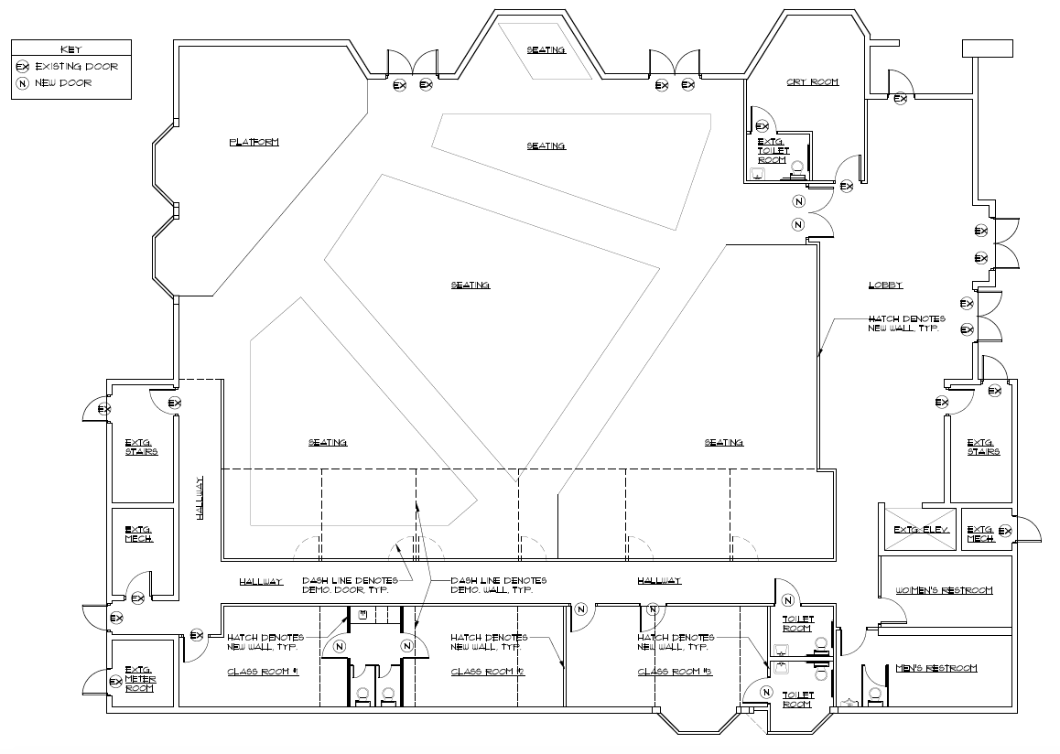
Renovations to the new building are beginning, and for the first time in the history of our church, we are creating our own worship space – without the limitations of when or where we can meet.

And while it’s not easy, quick, or cheap, to transform an office building into a church, your giving to the TRANSFORMED Special Offering will help us create a worship space where thousands will come to Christ in the years to come. This is an investment, not in a building, but in changing lives for eternity!

[PIC CAPTION: Architect’s rendering of the worship and Kidz ministry space in our new building]]

Providing a permanent ministry center where we can reach out to and serve our community

One of the greatest challenges our church has faced in the last 6 years is being visible for only a few hours on Sunday in rented facilities. With the opening of our new building, we will now have a 24/7 presence in our community. And while we know that the church is not a building (it’s the people), for those in our community that we want to reach and serve, completing this new building provides a sense of stability, presence, and opportunity will extend our impact far beyond Sunday.

When you give to the TRANSFORMED Special Offering, you are helping provide a ministry center that will impact our community for years to come.

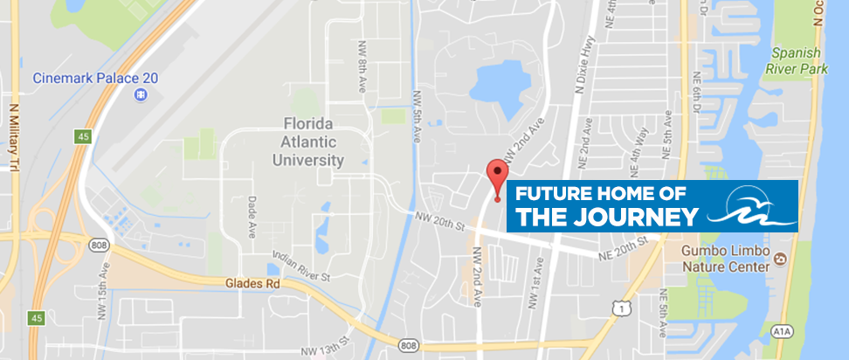

Transforming OUR CITY Through Evangelism & Community Ministry

Sharing God's love through ongoing evangelism efforts in our community
A recent Barna Research Study showed that our community leads the nation in the percentage of people who have NEVER been to church, and that South Florida is one of the most “unchurched” areas of the country. In fact, 83% of the 420,000 people who live within 7 miles of our church do not have a relationship with Jesus Christ. There are literally thousands of people within our sphere of influence who desperately need the hope and saving power of Jesus in their lives.

The TRANSFORMED Special Offering will help expand our evangelism efforts here in South Florida, including our Servant Evangelism efforts and other creative outreaches, so that we can continue to reach our community with the love of Jesus.

Reaching College Students through New Outreach Initiatives at FAU
One of the areas of our community that we most want to reach are the students at FAU. With the opening or our new building in Spring 2018, we will be within walking distance of thousands of students who attend FAU. We have piloted some early outreach efforts on campus this fall, and through your giving to the TRANSFORMED Special Offering we will be able to expand those efforts and help reach college students for Christ.

To meet the spiritual and physical needs of the poor in our area through Community Ministry
We are a church that serves the “least of these”. Through the TRANSFORMED Special Offering we will expand our partnerships with local organizations that are meeting the physical and spiritual needs of those in our community.

One of those partners is Boca Helping Hands, which provides meals, medical care, job training and placement, backpack programs for children in need, and more right here in our community. As a church, we can make a difference in their lives through our serving and giving.

(Jesus) “I tell you the truth, when you did it to one of the least of these my brothers and sisters, you were doing it to me!” – Matthew 25:40

[INCLUDE IMAGES OF SERVANT EVANGELISM, BOCA HELPING HANDS ATTACHED TO EMAIL WITH THIS CAPTION: Your gifts to the TRANSFORMED Special Offering help provide food, medical care, and job training to families in need our community.

Transforming OUR WORLD Through Supporting National and International Missionaries

Equipping Missionaries who are sharing Christ and starting new churches in the US and Canada
We are a church that supports missions. This focus will continue through our TRANSFORMED Special Offering as we have a great opportunity to join with other mission-minded churches to support 5,600+ missionaries in the U.S. and Canada, many of whom are starting churches just like The Journey in various languages in some of the most unchurched areas in North America.

Supporting Missionaries who are taking the Gospel around the globe
Through our TRANSFORMED Special Offering we will also support 4,200+ missionaries around the globe who are reaching out to every identified people group, especially those in highly unchurched countries.

These missionaries are serving in some of the world’s most important (and most dangerous) mission fields. Through our support, and the support of other like-minded churches, we can literally make a difference around the world as new churches are established and people come to know Christ.

Fulfilling the Great Commission to take the Gospel to the ends of the earth
In Matthew 28:19-20 Jesus gave us a mission to take the Gospel to the ends of the earth:

“Therefore, go and make disciples of all the nations, baptizing them in the name of the Father and the Son and the Holy Spirit. Teach these new disciples to obey all the commands I have given you. And be sure of this: I am with you always, even to the end of the age.” – Matthew 28:19-20

Through the TRANSFORMED Special Offering we will be able to help fulfill the Great Commission in 2018.

[INCLUDE THE IMAGE FROM IMAGE OF THE AFRICAN GIRL FROM THE 2015 PACKET WITH THE CAPTION: Your gifts to the IMPACT Special Offering help those in greatest need around the world.

ALSO INCLUDE THE IMAGES FROM SYRIA ATTACHED TO THE EMAIL WITH THE CAPTION: Missionaries provide medical care and share Christ with Syrian refugees.

To meet the spiritual and physical needs of the poor in our area through Community Ministry.
We are a church that serves the “least of these”. Through the IMPACT Special Offering we have a unique opportunity to help those in the greatest need in our community (both spiritually and physically). We will continue to partner with local organizations that are making a real difference in the lives of the less fortunate.

In South Florida, there are 690,000 people living in poverty, with 214,000 being children. That means almost 1/3 of those hungry are children.
In Palm Beach County and Broward Counties alone, 149,640 children go to bed hungry every night, and one out of four people receiving food at places like Boca Helping Hands is a child.

The need in our area is great. And that’s why through the IMPACT Special Offering we will be able to strengthen our partnership with Boca Helping Hands, providing meals and serving the poor and needy in our area. As a church, we can make a difference in their lives through our serving and giving.

(Jesus) “I tell you the truth, when you did it to one of the least of these my brothers and sisters, you were doing it to me!” – Matthew 25:40

[INCLUDE IMAGES OF BOCA HELPING HANDS ATTACHED TO EMAIL WITH THIS CAPTION: Your gifts to the IMPACT Special Offering help provide food, medical care, and job training to families in need our community.

FREQUENTLY ASKED QUESTIONS

Why a Special Offering?
As part of God’s plan to grow the faith of the people in His church, He calls us to sacrificial giving from time to time. This Special Offering is an opportunity for us to grow in our faith and to prepare us for what God wants to do through our church in 2018. This offering is not because we are behind on budget, but rather is to position us to make a greater impact in our community, in our church and around the world in 2018.

What’s the Difference Between the Regular Offering and this Special Offering?
The regular Journey offering is the proportional amount (the full tithe of 10%) that we set apart on a systematic basis and give throughout the year. From time to time there are opportunities to give in a sacrificial way. This Special Offering is one of those sacrificial occasions that stretch us to grow in our faith, and should be over and above what you regularly give.

How Much Should I Give?
Since the goal is $26,000, this Special Offering will involve everyone. Please prayerfully consider a sacrificial gift that will stretch your faith. The precise amount you give is between you and God. Many in our church can give a $1,000, $2,000 or even a $5,000 gift. Others will be able to give between $100 and $500. The issue is not equal giving, but equal sacrifice. What amount can you give that will stretch your faith?

Why is the Goal So Large?
We are a church that dares to dream big dreams for God. The ministries supported by this offering are BIG – supporting global and U.S. missions, sharing God’s love with our area through Community Ministry, completing the worship space in our new buidling. Big dreams require big faith and big funding. The accomplishment of these big dreams will be determined by your gifts to this Special Offering.

When Should I Give?
The best time to give will be the first Sunday after you receive this packet. Please pray about making your best gift on that day. However, you can continue to give until January 31, 2018. Please use the “TRANSFORMED” area on the regular offering envelopes or include a note designating that your gift is for the Special Offering. Remember, consistent gifts over time add up – a person giving $50 per week over a ten-week period will give $500 to this Special Offering.

Can I Give Online, Via Bank Check, Through Auto-Debit, or By Text Giving?
Yes. When you give at BocaJourney.com via online giving, simply select “TRANSFORMED” special offering under the “Fund” drop-down menu. Likewise, you can use your bank online payment option to send a check directly to the church office. Again, simply mark in the memo area that your gift is for the “TRANSFORMED” special offering.

In addition, you can also give to the Special Offering via a simple text message. If you’ve never given to The Journey via text message, just text the word “Give” to 561.962.1772. You will receive an immediate response with instructions on setting up your account (it takes less than 60 seconds). Then, you can simply give to the TRANSFORMED Special Offering by texting the word TRANSFORMED and the amount of your gift (i.e. Transformed 500 or Transformed 1000).

If you would like to make a special, one-time auto-debit over and above your regular giving, simply call 561.420.0606 x3 and speak with Pastor Jason – it’s simple and easy.

Can I Give In-Kind Gifts of Stocks or Bonds?
Of course! Since The Journey is a non-profit organization there can be tremendous tax benefits for you by giving in-kind gifts. For information on this type of giving, simply contact Pastor Jason at jh@bocajourney.com or 561.420.0606 x3.

Are My Gifts Tax-Deductible?
All gifts to The Journey, whether via the regular offering or this Special Offering, are completely tax-deductible. Your gift will be deductible in the tax year given (i.e., gifts given in 2017 will be deductible on your 2017 taxes).

Please be sure to include your name and address when you give so that a receipt can be sent to you for your tax preparations. You are not required to utilize a tax-deduction for your gift, but it is available for all gifts.

How Did We Arrive at a $24,600 Goal?
The $26,000 goal was prayerfully set by The Journey Pastors. It is approximately four times our regular weekly giving. It is a God-sized goal that can only be accomplished through 100% participation and sacrificial giving by our Journey attenders and members. Since we are expecting God to bless this Special Offering, it has been determined that any amount over and above our goal will be divided equally between Missions and Ministry Advancement.

How Will I Know if We Reach Our Goal?
Please pray for God’s guidance as we all give sacrificially. You will be updated on our giving progress through our weekly email updates and during the Sunday services. Reaching this goal will be a celebration of what we can do together as we stretch our faith under God’s leadership.

Have additional questions? Please contact Pastor Jason at jh@bocajourney.com, or call 561.420.0606 x3.

